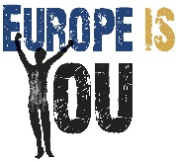
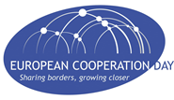
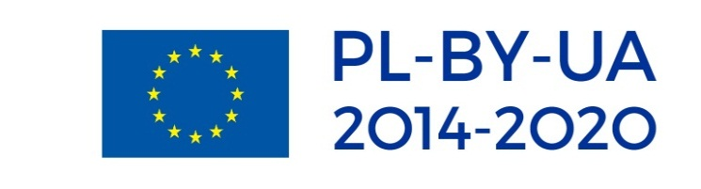

CROSS-BORDER COOPERATION PROGRAMME
POLAND-BELARUS-UKRAINE 2014-2020

European Cooperation Day – 2019
OPEN DAY FOR YOUNG PEOPLE

Brest, Belarus
28th September 2019

AGENDA

10:45 – 11:00 | Registration of participants, welcome coffee
11:00 – 11:10 | Welcome speech of BBO. Short overview of the Programme and its opportunities for youth.
11:10 – 11:50 | Presentation of projects within 2007-2013 and 2014-2020 with an emphasis on young generation interests
11:50 – 12:20 | BY-finalists of the Cross-border educational campaign share their opinion about participation in the Final event of the school competition
12:30 – 13:30 | Lunch
13:30 – 14:00 | Visiting an Interactive Museum of Historical Development of the Fire Service of Brest Region created within PBU/0754/11
14:00 – 16:00 | Drawing “Europe is You”/Optional (for those who will not participate in the drawing) communication of youth in informal surroundings on a topic “Europe is You” /participation in a quiz
16:00 – 16:10 | Summing up, awarding the winners of the best art works

